

# PE Coach

**Full Time**

**Tufnell Park Primary School**

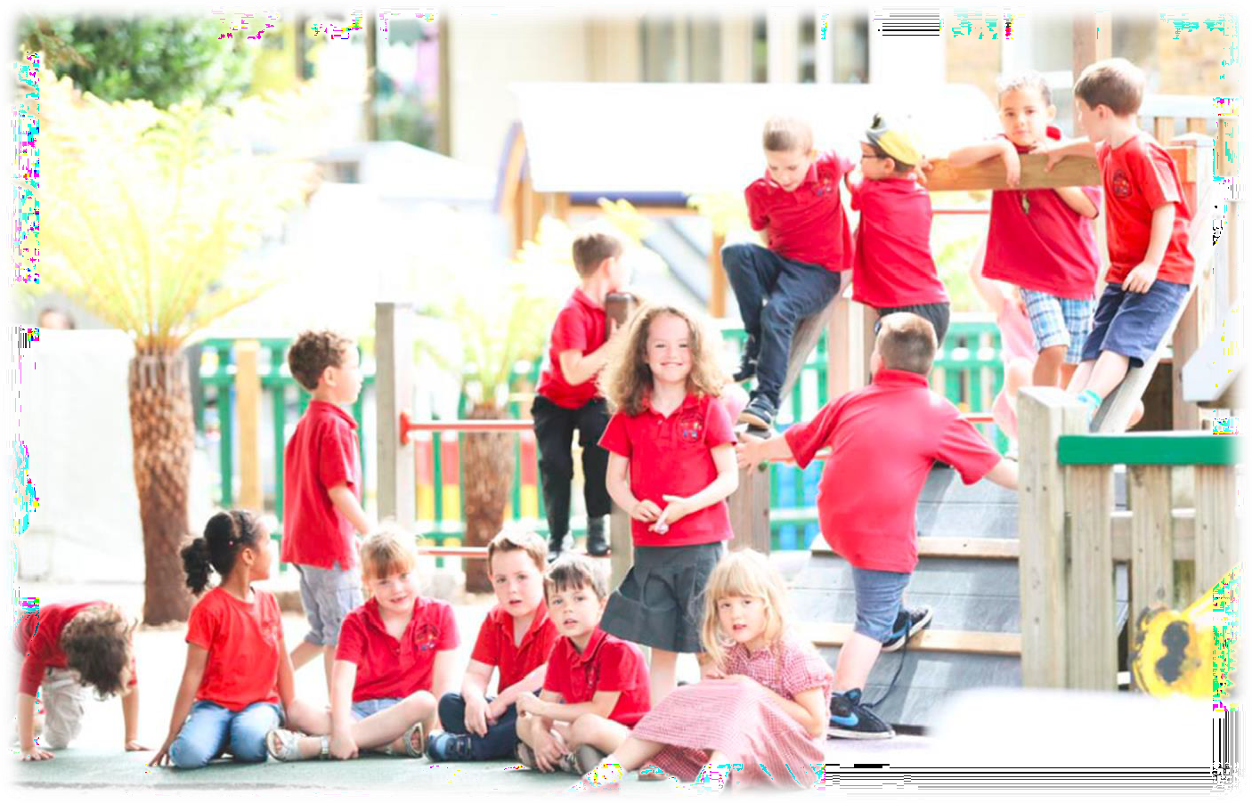

## Closing Date: 9am Monday 15th of July



**Contents page**

|  |  |
| --- | --- |
| Letter from the Headteacher | **3** |
| About the School | **4** |
| Advert | **6** |
| Job Description | **7** |
| Person Specification | **10** |
| Additional Information | **12** |

|  |  |
| --- | --- |
|  | Tufnell Park Primary School  31 Carleton Road, London N7 0HJ admin@tufnellpark.islington.sch.uk  020 7607 4852 |

Dear Applicant,

I am delighted that you are interested in joining the team here at Tufnell Park. I would like to take this opportunity to tell you a little more about our school.

Tufnell Park is a happy and dynamic primary school with nursery. Although we are mainly one-and-a-half form entry, we have begun the process of expanding to three forms of entry, now at Year 3, with a full cohort of 90 children in Reception since September 2021. We also have a 52 place Nursery and a provision for two-year-olds.

Exciting times are ahead for those who join our team. In September 2019, we moved into a stunning brand new building, with expanded state of the art facilities reflecting the high aspirations we hold for our community. We are excited by the development this is promoting, whilst carefully striving to retain the current ‘feel’ of our smaller school where every child is known. If you have the drive and ambition, many varied opportunities exist to be part of shaping the future here at Tufnell Park, whilst developing your own practice and career.

We are currently a good school (Ofsted, October 2022) but have high aspirations to improve further in all areas, and the capacity to do so. We are seeking staff with the drive and creative spark to devise and shape purposeful experiences that ensure all our children become responsible, resourceful and resilient citizens, as well as passionate advocates for the natural environment and expert users of technology. We are very excited by the prospect of extending our wraparound care, bringing it in-house to make use of the amazing facilities here at school, as well as providing a vital high-quality service to our parents and community.

Like many inner-city primary schools, our children come from a wide range of backgrounds, including some families in difficult circumstances. This makes Tufnell Park a challenging and rewarding place to work. To be appointed to our school, we would expect you to be committed to improving children’s life chances. You can expect from us a commitment to your own professional development, a supportive leadership team and a wonderful group of teaching and support staff, who really believe in our children and their ability to succeed. We are well supported by a very effective governing body and an active Parent Teacher Association, ensuring our community is fully engaged in the life of the school.

I would love for you to visit us and get a sense of what Tufnell Park is all about. Please call or email Renata Flavell (our Office Manager) to make an appointment.

I look forward to hearing from you,



Martin Scarborough – Headteacher

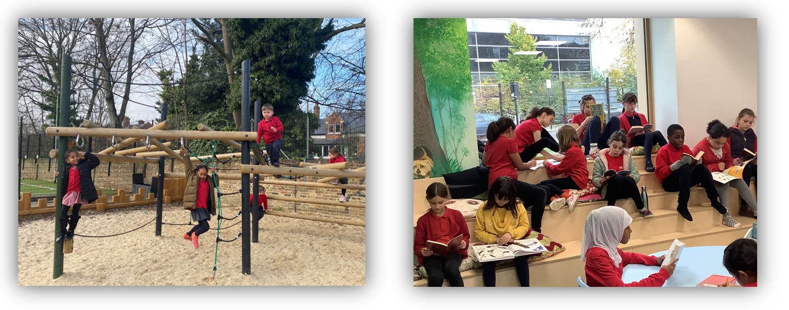

**About the school**

Tufnell Park is a great place to work and is a positive environment where everybody works together to achieve. We are currently one-and- a-half form entry but are in the process of expanding to three forms of entry. In September 2019 we moved into a brand new, state-of-the-art building to match our high aspirations, with additional dedicated teaching facilities, including a teaching kitchen, a music/dance studio and SEN suite with sensory room.

Our site on the brow of a hill gives wonderful views across North London—big skies and wide horizons are always in evidence. We are surrounded by natural wildlife spaces and mature trees, so we are able to enjoy a peaceful and containing space that brings us close to nature, whilst still being only minutes away from the heart of London and all that offers.

We are situated in area of wide-ranging social context, between areas of Victorian housing and local authority housing estates, making our intake diverse and fully reflective of the local community. 41% children come from minority ethnic families, and 31% speak English as an additional language, with over 30 home languages represented. The school has higher

than average mobility compared to schools nationally, with some children arriving from overseas, often with no English and little/no formal education.

The school has an excellent and committed staff who work together as a team, and who have an enthusiasm for and commitment to child- centred learning. There is a culture of collaboration, mutual support and respect which extends to everybody connected with Tufnell Park.

We are very proud of our wonderful children. They are caring and considerate, using their initiative to help themselves and others, and show exceptionally positive attitudes to learning.

All children learn through an exciting curriculum which seeks to inspire them as confident and independent learners. We are committed to children’s learning, progress and high achievement, whilst also ensuring we provide relevant and enjoyable experiences for our children. We aim to foster their long-term development, our school providing a safe and friendly environment that ensures every child receives the best possible start on their life-long learning journey.



### Our Vision

At Tufnell Park every child flourishes into a resourceful, resilient and responsible citizen, developing the knowledge, skills and attributes required to thrive in the wider world.

Children experience a rich, purposeful and balanced curriculum, enhanced by a range of cultural, artistic, sporting, civic and real-life experiences to broaden their horizons, through the Tufnell Park Promise. Staff and pupils strive for excellence in all areas, leading to the school becoming the first choice for parents in the area.

Our school community have identified two particular aspects of learning to prepare our children for future success. The intention is that all children become:

* **Skilled and discerning users of technology, developing their own creativity and ingenuity to enhance their learning and solve real world questions and problems**
* **Passionate, knowledgeable advocates for the natural environment, for sustainable practices, and for healthy, active lifestyles**

**P.E. Coach**

|  |  |
| --- | --- |
| **Contract:**  Permanent | **Hours:**  Full Time |
| **Salary Scale:**  Unqualified Teacher scale | **Actual Salary:**  £25,831 – £37,362 |
| **Start Date:** 03.09.2024 | |

The Headteacher and Governing Body invite applications from highly motivated, knowledgeable and organised individuals to join our team.

We are looking for an outstanding candidate to contribute to our already flourishing PE curriculum and out of school hours sports offer. The successful candidates will be proactive, dependable and able to work collaboratively with colleagues, pupils and members of the wider school community.

We have begun the process of expanding to three forms of entry and have recently moved into a beautiful state of the art new building. Tufnell Park is a great place to work and has a positive environment where everybody works together to achieve. The school is situated on a spacious and peaceful corner site with natural wildlife gardens and mature trees, yet convenient for transport links to North and Central London.

We can offer you:

* a welcoming and enthusiastic environment with a talented and dedicated staff team
* an opportunity to make a real difference in the lives of young people
* a supportive leadership team with great opportunities for CPD
* an engaged and inclusive school community where everyone is valued

Visits to the School are welcomed and encouraged. Contact Renata Flavell on 020 7607 4852,

or by email at [admin@tufnellpark.islington.sch.uk](mailto:admin@tufnellpark.islington.sch.uk)

Also do explore the [website](https://tufnellpark.islington.sch.uk/) for videos, virtual tours and information, to find out what makes us special.

**How to apply:**

To apply for this post, please visit: <https://jobs.islington.gov.uk/> and search for Tufnell Park

If you need assistance, please email HR Team at [schoolsrecruitment@islington.gov.uk](mailto:schoolsrecruitment@islington.gov.uk). For an informal discussion about the role, please contact the school directly. Please note CVs are not accepted in line with Safer Recruitment practices.

Closing date for application: **9am on Monday 15th July 2024**

Selection and Interviews: **Week commencing 15th**

**July 2024**

Tufnell Park is committed to safeguarding and promoting the welfare of children and young people, and expect all staff and volunteers to share this commitment. An enhanced DBS (Disclosure and Barring Service) with barred list check will be required. In addition, if this post is likely to come under the requirements of the Childcare (Disqualification) 2009 Regulations and the successful applicant will be required to declare.

In line with KCSIE 2023 and safer recruitment practices, the school will conduct an online search for all shortlisted candidates. The online search is part of our safeguarding checks and will seek publicly available information on candidates’ suitability to work with children. Shortlisted candidates will be provided with further guidance and will be asked to clarify their online presence.

Please note the advertised actual salary is a range based on continuous service, with the maximum range indicating 5+ continuous years with local government/schools. The starting salary will be calculated based on the individual circumstances of the successful candidate/s.



**Job Description**

|  |  |
| --- | --- |
| **POSITION SCHOOL RESPONSIBLE TO**  **GRADE** | **PE Coach**  **Tufnell Park Primary School Headteacher and Deputy**  **Unqualified Teacher Scale £25,831 – £37,362** |
|  |  |

**PURPOSE OF THE POST**

To plan, deliver and monitor a co-ordinated programme of high quality, professional PE lessons, sporting and festival activities that are progressive and reflective of the needs of the children and support the aim of increasing participation in PE and school sport by ALL children at Tufnell Park Primary School.

**DUTIES AND RESPONSIBILITIES**

1. To plan and implement well-structured and progressive PE lessons within the school’s curriculum ensuring a high quality, enjoyable coaching experience centred on the needs of the children.
2. To organise out of school coaching programmes
3. To deliver coaching in a range of sporting activities that covers the PPA time of teachers within the school’s PE curriculum and to have a focus on out of hours enrichment sporting activities.
4. To organise inter-school and intra-school sporting competitions for children.
5. Maintain appropriate records, player registration forms and prepare monitoring reports. Submit reports when required to the school Governors.
6. To be a positive role model, creating a positive and fun environment in which to motivate and encourage children to participate in sport and physical activity.
7. Take positive steps to identify and overcome barriers to participation amongst children, prioritising access and inclusion.
8. To agree to abide by the school’s code of conduct, including professional behaviour, relationships and appearance.
9. To adhere to a standard of dress that reflects the professionalism and active nature of the role. Always considering your position as a role model to children.
10. To carry out duties in accordance with school’s policies, including equal opportunities, child protection, health and safety at work.
11. To develop and maintain effective and positive working relationships with all staff, including the wider school community and external sporting organisations
12. To attend appropriate professional development courses as identified through the post-holders training needs analysis.
13. To ensure contacts are made with external sporting bodies to enable signposting opportunities are made available to specific groups or individuals.
14. To keep notes of assessments of each child to ensure progression of skills, knowledge and to show outcomes.
15. To provide high quality written reports on each child, that contribute to the annual report given to parents during the summer term.
16. Maintain the positive ethos and core values of the school, both inside and outside of the classroom.
17. Teach all aspects of the PE national curriculum to children across EYFS, Key stage 1 and Key stage 2.
18. Safeguard the pupils and your own safety when on and off the school premises.
19. Attend and contribute to the school staff meetings as requested
20. Organise cross-curricular and extra-curricular PE and sport across the school.
21. Organise and support PE events, tournaments, sports days etc. When required.

**PLANNING**

1. Use the school agreed formats.
2. Plan appropriately to the meet the needs of all pupils, through differentiation of tasks to match pupil’s individual needs.
3. Keep accurate and up to date assessment records.
4. Set clear targets, based on prior attainment for pupils’ learning.
5. Keep appropriate and efficient records, integrating formative and summative assessment into weekly and termly planning.
6. Report to parents on the development, progress and attainment of pupils.
7. Show an awareness of equal opportunities in all aspects of the day to duties relating to staff and pupils and the school community.

**TEACHING AND LEARNING**

1. Use appropriate teaching methods in line with the school policies.
2. Have high expectations of behaviour and discipline in accordance with school’s behaviour policy.
3. Effectively deploy and manage support staff to meet pupil needs.
4. Review, evaluate and set pupil targets.
5. Provide a stimulating learning environment, where resources can be accessed appropriately by all pupils.

**DEVELOPING STAFF**

• Monitor provision and outcomes with appropriate rigour, and coach/mentor colleagues and lead in-service training to improve provision, as required.

• Promote links and co-operation with teaching and non-teaching staff.

• Ensure that senior colleagues and governors are informed about relevant policies, plans, priorities, targets and outcomes.

• Champion new curriculum thinking, teaching methods, and use of new technologies.

**ASSESSMENT AND EVALUATION**

• In collaboration with the Assessment Leader, establish and implement clear practices for assessing, recording and reporting on pupil achievement, in line with school policy.

**MANAGING RESOURCES**

• Use accommodation to create an effective and stimulating environment for teaching and learning.

• Advise senior leaders of resource needs.

• Ensure the effective and efficient management and organisation of learning resources.

• Ensure that there is a safe working and learning environment in which risks are properly assessed.

**CONFIDENTIALITY**

• The nature of the job requires a high degree of initiative, confidentiality, tact and discretion when giving

or receiving information which could be confidential.

**SPECIAL FACTORS:**

**Special conditions given below apply:**

1. The nature of the work may involve the post holder carrying out work outside of normal working hours to accommodate sports events and competitions.
2. From time to time the post holder will be required to attend training courses, seminars and meetings as required and in addition by the needs of the school.
3. The post is subject to an enhanced Disclosure and Barring Service check.

This job description sets out duties and responsibilities of the post at the time when it is drawn up. Such duties and responsibilities may vary from time to time without changing the general character of the duties or the level of responsibility entailed. Such variations are a common occurrence and cannot themselves justify a reconsideration of the grading of the post.

The title of the post to which I normally report is: **Headteacher**



**Person Specification**

|  |  |
| --- | --- |
| **POSITION SCHOOL RESPONSIBLE TO**  **GRADE** | **PE Coach**  **Tufnell Park Primary School Headteacher and Deputy**  **Unqualified Teacher Scale £25,831 – £37,362** |

|  |  |  |
| --- | --- | --- |
| **E1** | At least 4 years’ experience working with children in a mainstream primary school. |  |
| **E2** | Experience teaching sport to children. |  |
| **E3** | Experience coaching children, to recognised attributes laid out by national sporting bodies. |  |
| **E4** | Relevant nationally recognised coaching qualifications. |  |
| **E5** | Excellent communication skills orally and written, including confident presentation to groups of children. |  |
| **E6** | Demonstrate ability to use own initiative and work without close supervision. |  |
| **E7** | Excellent organisational ability. |  |
| **E10** | Ability to plan a sequence of PE lessons that build upon prior knowledge and skills. |  |
| **E11** | Experience of positive impact on the educational progress of children. |  |
| **E12** | Evidence of a commitment to an equal opportunities policy both in service delivery and employment,  and an understanding of its effective operation within a school. |  |
| **E13** | An ability to ensure that each child’s identity is respected, maintained and enhanced, and that  stereotypes are challenged in a sensitive way. |  |



**Additional information**

# How to apply

Please visit [www.islington.gov.uk/jobs](http://www.islington.gov.uk/jobs) to apply for the post. Please do not send your application documents to the school.

Closing date for applications is 9am on Monday 15th of July 2024

# Visits to the school

# Visits to the School are welcomed and encouraged. Contact Renata Flavell on 020 7607 4852, or by email at admin@tufnellpark.islington.sch.ukAdditional queries

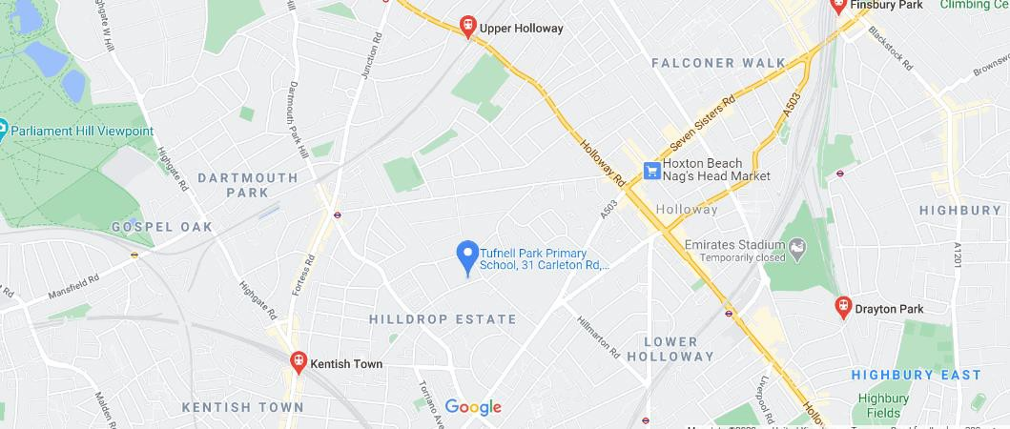

Should you have any queries regarding the application process please contact the Schools HR team at [schoolsrecruitment@islington.gov.uk](mailto:schoolsrecruitment@islington.gov.uk)

# School address and location map

Tufnell Park Primary School 31 Carleton Road

London N7 OHJ

 Gospel Oak Station

* Upper Holloway Station

 Kentish Town Station

 Holloway Station

 Caledonian Road Station

