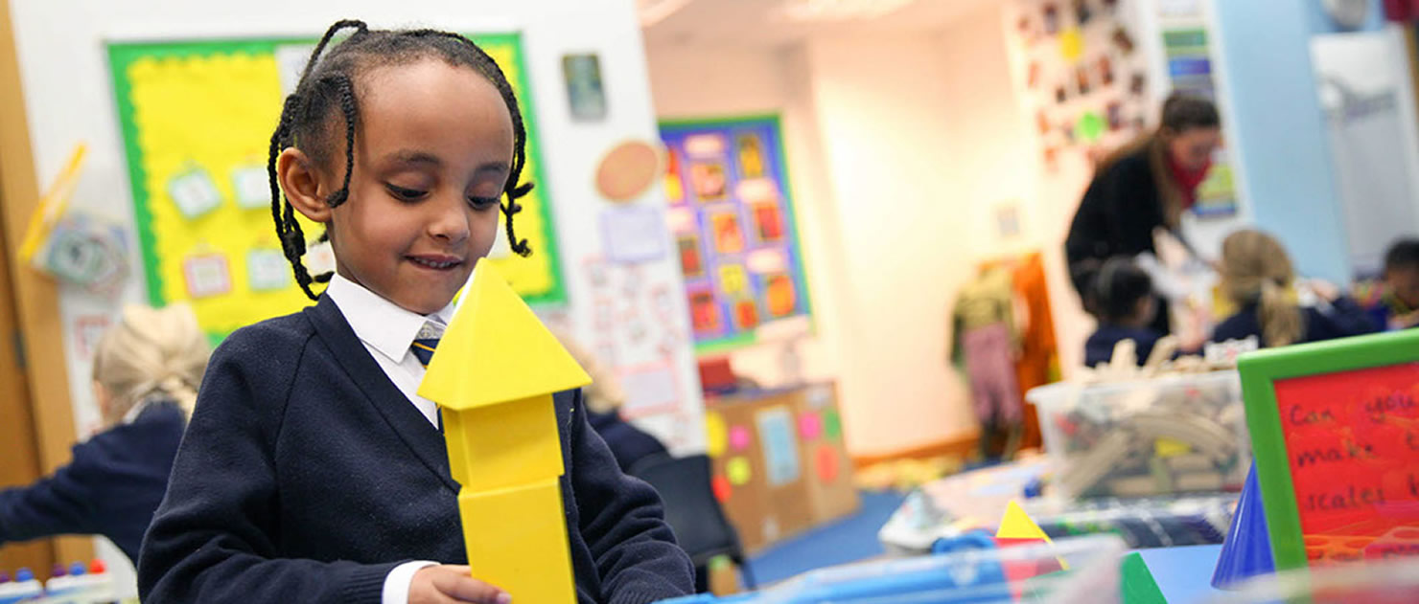
Class Teacher
St Peter and St Paul Catholic Primary School
Ref: SPSP/907
Closing date: midnight, 7 July 2024
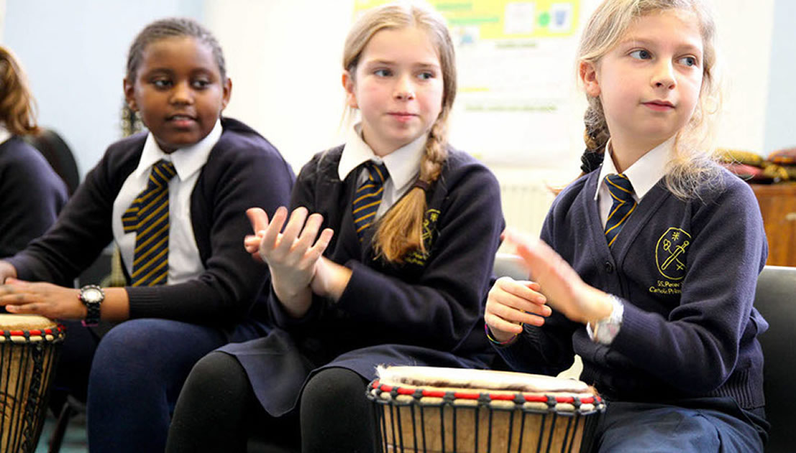
Contents

Letter from the Headteacher
About the school
Advert
Job Description
Person Specification
How to apply

Address- St Peter and St Paul Catholic Primary School,

Compton Street, Goswell road

London EC1 0EU

Email: admin@stpetersstpauls.sch.uk

Contact- Tel- 020 7253 0839

Fax- 020 7336 7226

Letter from the Headteacher

Dear Candidate,
Thank you for your enquiry regarding the teaching vacancy at St Peter and St Paul Catholic Primary School. Please find attached a teacher application form for your completion, job description and personal specification.
Closing date for applications is: midnight, Sunday 7 July 2024
Interviews will be held Wednesday 10 July 2024

St Peter and St Paul Catholic Primary School is committed to safeguarding and promoting the welfare of children and young people, and expect all staff and volunteers to share this commitment. This position is subject to enhanced Disclosure and Barring Service check.

In line with current safe recruitment guidelines, references will be taken prior to interview.
If you haven’t already done so, visits to the school are very welcome and can be arranged through the: parentsupport@stpetersandstpauls.islington.sch.uk.
I look forward to receiving your application form.
Yours sincerely

Tracey Peters
Head teacher
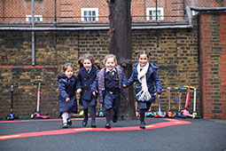
About the School

- Are you looking for a school that embodies their mission statement ‘To love one another’
- Do you put children at the forefront of every decision you make in school?
- Are you professional, approachable, enthusiastic and organised?
- Are you an existing Senior Leader in a primary school?
- Are you aspiring to Headship in the future?
- Are you ready for an exciting new challenge?
- If so, then this could be the next job for you.
St Peter and St Paul Catholic Primary School is a one form entry primary between the Barbican area and Angel looking to recruit our next Deputy Head, following the successful appointment of our current Deputy Head to Headship at another school.
St Peter and St Paul Catholic Primary School was judged to be good by Ofsted at its last inspection in 2018. Stating that the pupils:
‘are attentive to their teachers ……..and proud of their achievements.’

We will offer you:
- A caring, welcoming school where Christ is at the centre and underpins all that we do
- Amazing children who are engaged, enthusiastic and ready to learn
- A friendly, enthusiastic, ambitious and supportive staff
- A determined and passionate Head teacher and Senior Leadership Team
- A strong commitment to your professional development
- Supportive parents

Class Teacher
Advert

Required for 1 September 2024
Salary: £36,745 to £47,666
Contract: Permanent

St Peter and St Paul is a successful, one-form entry Catholic primary school situated in the vibrant and diverse borough of Islington. We strive to bring out the best in all of our pupils; they demonstrate an excellent attitude to learning and attain high academic standards. The Governing Body is seeking to appoint a highly motivated and creative Class Teacher to join our team.

The successful candidates will:
- Support the Catholic ethos of the school
- Have high expectations of pupils and be excellent classroom practitioners
- Be able to communicate effectively with children, parents and staff
- Be able to work as part of a friendly and successful team

We offer:
- Enthusiastic, hardworking pupils who have ‘outstanding’ behaviour
- Excellent teaching and learning resources
- Supportive parents and School Governing Body
- Opportunities for continuing professional development

We strongly encourage all interested applicants to visit our school community, facilities and outdoor space. Visits to the school are very welcome and can be arranged through Maria Bennett 020 7253 0839 or mariabennett@stpetersandstpauls.islington.sch.uk
To apply for this post, please visit www.islington.gov.uk/jobs. If you need assistance, please email HR Team at schoolsrecruitment@islington.gov.uk
The closing date for applications is midnight 7 July 2024
Interviews: Wednesday 10 July 2024
Job Description

POSITION Class Teacher
SCHOOL St Peter and St Paul Catholic Primary School
RESPONSIBLE TO Head Teacher
GRADE MPS, M2-M6 (Inner London)

General Duties
The education and welfare of a group of students in accordance with the requirements of the “Conditions of Employment of School Teachers” having due regard to the requirements of the National Curriculum. To uphold the school’s aims, objectives and schemes of work and any agreed and established school policies. To share in the corporate responsibility for the well-being and discipline of all students.

To provide excellent opportunities for the development of the allocated age pupils. To ensure care and maintenance of a safe and stimulating learning environment. To establish and maintain positive relations with pupils, parents and the wider school community.

Purpose of job
- To be sympathetic towards our strong Catholic ethos
- To be an effective and reflective classroom teacher able to demonstrate and share good practice.
- To plan and prepare lessons with regard to individual need, with reference to school policies, national requirements and local policies.

Main Duties and Responsibilities
- To ensure the maintenance of good order and discipline among all pupils and safeguard their Health and Safety, both on school premises and when they are engaged in authorised activities elsewhere.
- To provide professional leadership and direction within own curriculum area by acting as a good role model
- To ensure that own practice and that of other staff in own area of responsibility improves the quality of education and raises standards through monitoring of teaching and learning.
- To co-ordinate assessment and record keeping procedures in our class and reporting on student’s attainment and progress.
- To prepare for and lead staff meetings where appropriate
- To work with Senior Management Team and the inclusion team, ensuring that the needs of all pupils are met.
- To prepare displays, prepare assemblies, organise and lead parent/carer meetings as appropriate to promote understanding and development of own area.
- To keep abreast of current good practice through reading, attending courses, evaluating materials, resources and ideas and visiting schools.
- To manage, where relevant, own budget effectively and efficiently ensuring that financial regulations are adhered to.
- To manage and organise non-teaching staff.
- To establish a partnership with parents involving them in their child’s learning through regular communication, after school clubs, workshops and homework etc.
- To be responsible for creating a stimulating environment in which pupils reach their full potential.
- To be responsible for writing annual reports on the students assigned to you.
- To be able to work effectively and co-operatively within a multi-disciplinary team.
- To be aware of the schools and the local Education Authority’s Equal Opportunity Policy, ensuring that all children have full access in order to maximise their achievement and minimise inequality.

This job description may be amended at any time after discussion with you but in any case it will be reviewed one year after appointment.

Accountability;
- Teachers are responsible to the Head teacher and, in her absence or on her behalf, the Deputy Head Teacher/Assistant Head teacher
- Teachers are accountable to parents/carers and are in loco parentis when engaged in authorised school activities.
- Teachers are responsible for the curriculum they provide which should reflect school and local education policy and Government legislation.

Equal Opportunities
- To take responsibility, appropriate to the post for tackling racism and promoting good race, ethnic and community relations.

Safeguarding
- To have a due regard for safeguarding and promoting the welfare of children and young people and to follow all associated child protection and safeguarding policies as adopted by the school and Local Authority.

Data Protection
- When working with computerised systems to be completely aware of responsibilities at all times under the Data protection Act 1984 for the security, accuracy, and significance of personal data held on such systems.

Commitment
- To be aware of all Equal Opportunities implications within our school, and lead on their continued development
- To ensure that the school’s customer care standards are met and adhered to.

Personal Responsibilities
- To carry out the duties and responsibilities of the post, in accordance with the school’s Health and Safety Policy and relevant Health and Safety Guidance and Legislation.
- To use information technology systems as required to carry out the duties of the post in the most efficient and effective manner.
- To undertake training and professional development as appropriate.
- To ensure compliance of procedures are observed at all times under the provision of safe systems of work through a safe and healthy environment and including such information, training instruction and supervision as necessary to accomplish those goals.
- To undertake other duties appropriate to the post that may reasonably be required from time to time.
- Ability to form and maintain appropriate relationships and personal boundaries with children and young people.
- To carry out general porterage duties as required and particularly the provision of furniture and other equipment to meet the needs of premises users for timetabled activities without continued instruction.

POSITION Class Teacher
Person Specification

SCHOOL St Peter and St Paul Catholic Primary School
RESPONSIBLE TO Headteacher
GRADE MPS, M2 – M6 (inner London)

The table below outlines the essential and desirable criteria, which will be used to select the candidate(s) for this post.

Criteria |  | Essential
Qualifications |  | - QTS  - Degree/Other professional qualification
Experiences |  | - Recent experience of working effectively with pupils in the primary stages  - Experience of primary teaching in an inner city primary school  - Evidence of using and being able to develop planning and assessment procedures  - Experience of working as part of a team  - Effective behaviour management, with clear boundaries, sanctions, praise and reward
Professional knowledge, skills and attributes |  | - Knowledge and experience of the characteristics of high quality teaching and the willingness to adopt new strategies for improving and sustaining high standards of teaching, learning and achievement for all pupils.  - Ability to identify, take direction and respond to key issues affecting pupil’s progress and performance.  - Knowledge of delivering the curriculum to children with complex needs  - Ability to set achievable targets and raise standards through planned activities and interventions.  - Ability to communicate effectively both orally and in writing with pupils, parents/carers, staff and the wider community.  - Ability to organise own workload effectively.  - A commitment to the regular and on-going professional development and training to establish outstanding classroom practice.
Personal Skills and attributes |  | - Aptitude to work as a team whilst being self-motivated and action orientated.  - Enthusiasm and energy to undertake the duties of this post in line with the teacher standards.  - Commitment to safeguarding the welfare of all pupils.  - We expect a candidate who has a sense of fun and likes children.

Application Deadline
How to apply

Completed application forms must be received by midnight, Sunday 7 July 2024. Please note that we only accept online application forms. CVs, hard copy or late applications will not be accepted.

To apply
Please apply online at www.islington.gov.uk/jobs. If you need any assistance, please contact Schools HR at schoolsrecruitment@islington.gov.uk quoting reference SPSP/907.

Further enquiries
If you have read the job description and meet the essential requirements identified in the person specification, please apply on line. For an informal discussion of the role, please contact the Headteacher at the school contact number.

School visits
Visits to the school are very welcome and can be arranged through the School Office on 020 7253 0839 or admin@stpetersandstpauls.islington.sch.uk

Completing your application
Please read the job description and person specification carefully. You should demonstrate on your application how you meet the requirements of the post according to your qualifications, skills, abilities and experiences. Please ensure to address each criteria of the person specification as this will be used to assess your suitability for the post.
Guidance notes on how to apply for a job within schools and the policy on the recruitment employment of ex-offenders are available as attachment within the online job listing. Please refer to those before submitting your application.

Shortlisting and selection procedure
The shortlisting and selection will be made by a panel of senior leaders and Governors. Shortlisted candidates will be notified immediately after shortlisting has taken place and will be provided with further information on the selection process.
We are planning the selection process to take place on 10 July 2024. The selection process may have a combination of tasks, activities, assessment tools and interview. Further information will be provided to the candidates shortlisted for interview.
Please would all applicants ensure that their preferred means of urgent contact (phone, mobile phone or e-mail) are clearly identifiable from the application form, so that your confidentiality is maintained.

References
Candidates are advised that references will be taken up during the shortlisting process. Candidates are asked to ensure that their referees are warned of the need to respond within the timescale set. In all cases at least two professional references are required.
The post will be offered subject to satisfactory completion of pre-employment checks.

Safeguarding children
Prior to appointment, formal checks will be made in accordance with the current statutory requirements relating to child protection.

