

KS1 and KS2 Leader
(0.5 class based)
For September 2026

Closing Date: Midnight 15th March 2026





Contents

Letter from the Head Teacher
Advert
Job Description
Person Specification

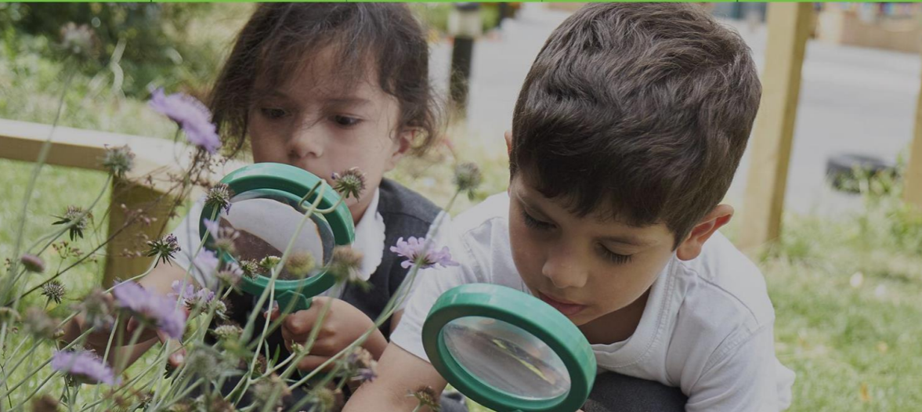
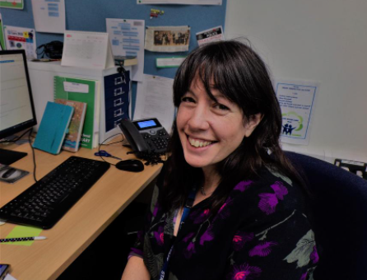

Letter from the Headteacher

Dear Potential Candidate

Thank you for your interest in the position of KS1 and KS2 Phase Leader at Moreland Primary School and Children’s Centre. Moreland is a unique and vibrant provision, offering exceptional care and education for children from 6 months to eleven years in a modern, purpose‑built environment with spacious, well‑equipped grounds. Following our successful Ofsted inspection in July 2025, we are excited to welcome new colleagues to join us as we continue our school vision.

Moreland sits at the heart of a diverse community in Islington, and we make full use of the rich opportunities our location provides. Our partnerships with local organisations and businesses, cultural institutions and community groups enable us to offer pupils a wealth of enrichment experiences that broaden horizons and bring learning to life. The school’s Learning for Life ethos is central to everything we do, and we are deeply committed to high‑quality professional development that empowers staff to grow, innovate and lead.

Our children and families are at the core of our work. We value the diversity, culture, knowledge and lived experiences they bring to our school, and we are proud to be an inclusive community where every child is known, supported and celebrated. We nurture self‑belief, resilience and a Growth Mindset so that pupils feel confident to take risks, embrace challenge and understand that determination and perseverance open doors. We work tirelessly to remove barriers to learning so that every child can reach their full potential.

At Moreland, collaboration and mutual respect underpin our culture. Staff, children, parents and governors work together with a shared purpose: to create a school where everyone feels they belong and where success is achieved collectively. There is a genuine collective sense of ambition and commitment across the team, making Moreland an inspiring place to work and learn.

“Reaching higher than I dreamed, becoming the person that I want to be, doing the best I can for the world and for me.”

This is our mission — and we are looking for a leader who will help us bring it to life for every child.

We look forward to receiving your application.

Please see the school website for information about the school. I would encourage you to come and see our wonderful school for yourself and visits are welcomed.

With best wishes,
Catherine Lawrence (Head teacher)
Why come to Moreland?

Information about the school
Moreland Primary School and Children’s Centre provides a seamless integrated service from pre-birth to the end of year 6. We have the privilege of working in a very rich and diverse community which includes many children and families from a range of backgrounds and cultures and this vibrant blend makes the Moreland community a unique and exciting place to work.

Why come to Moreland?
- The prospect of growing as a professional across a school and Children’s Centre
- Chance to work with other schools through the Federation and within the Future Zone collaboration of local schools and the opportunities this brings
- A chance to make your mark within the school and Islington
- Opportunity to work in a school with an inspiring curriculum
- Enticing Inner London pay rates
- Engaging and highly motivated team
- Highly supportive staff and dedicated governors
- Further Professional Development
- Excellent location at the heart of Islington and near the City of London

Moreland Primary School and Children’s Centre
Moreland Street
London
EC1V 8BB
Tel: 020 72538144

Ofsted Report
Latest reports on Moreland Primary School and Children’s Centre:
Inspection of a school judged good for overall effectiveness before September 2024: Moreland Primary School

School Website
Moreland Primary School and Children’s Centre website:
https://www.moreland-islington.co.uk/

Social Media
@morelandprimaryschool
 @morelandprimary

Visits
Visits to the school are highly encouraged and can be organised by contacting the school office.
Tel: 020 7253 8144.
Email: admin@Moreland.islington.sch.uk
You can find out more about our school by accessing our website: www.morelandislington.co.uk.

Applications
Contact the school office for an application pack.
Closing date: Midnight Sunday 15th March 2026
Shortlisting date: Monday 16th March 2026
Interview date: t.b.c

Moreland Primary School and Children’s Centre is committed to safeguarding and promoting the welfare of children and young people, and we expect all staff and volunteers to share this commitment. In line with KCSIE 2025 an online search will be carried out for all candidates. An enhanced DBS check is required for this post.

Moreland Primary School is committed to building a diverse, inclusive and equitable community where every pupil, family and member of staff feels valued, respected and able to thrive. We welcome applications from candidates of all backgrounds, identities and lived experiences, and we actively encourage those who are under‑represented in education leadership to apply.

Key Stage 1 & 2 Leader
(0.5 class teaching)
Main Scale - UPS + TLR 2b
Moreland Primary School, Islington
Learning for Life – Enrichment, Opportunity, Ambition

Moreland Primary School is a warm, diverse and proudly inclusive community in the heart of Islington. Guided by our Learning for Life vision, we are committed to providing every child with an education that opens doors, nurtures curiosity and builds the skills, confidence and character they need for the future.
We are seeking an exceptional KS1/KS2 Leader who shares our belief that all children deserve access to rich learning experiences and meaningful opportunities — regardless of background, need or starting point.

Our Vision: Learning for Life
At Moreland, we want every child to:
- develop a love of learning that lasts a lifetime
- experience a curriculum that is ambitious, inclusive and connected to the real world
- access enrichment that broadens horizons and builds cultural capital
- feel safe, valued and empowered to succeed

Your leadership will play a central role in realising this vision across Key Stages 1 and 2.

The Role
As KS1/KS2 Leader, you will:
- Model excellent classroom practice and inspire colleagues through coaching and collaboration
- Lead curriculum development that is creative, inclusive and rooted in high expectations
- Champion enrichment and ensure all pupils have equitable access to wider opportunities
- Use assessment intelligently to secure progress and build pupil confidence
- Strengthen partnerships with families and the wider community
- Contribute to whole‑school improvement with clarity, compassion and ambition

What We Offer
- A supportive, reflective and forward‑thinking staff team
- Children who are enthusiastic, curious and eager to learn
- A leadership culture that values innovation, professional growth and inclusion
- An exciting curriculum with a strong commitment to enrichment, opportunity and real‑world learning
- The chance to make a meaningful difference in a school with a clear, values‑driven vision
- Generous leadership time

Who We’re Looking For
You are an experienced, inspiring teacher with:
- a deep understanding of primary pedagogy
- a passion for widening access to enrichment and opportunity
- the ability to lead with integrity, optimism and high expectations
- a commitment to inclusive practice and equitable outcomes for all

If you are ready to lead with purpose and help shape the next chapter of Moreland’s Learning for Life journey, we warmly invite you to apply.

Job Description: KS1 & KS2 Phase Leader
Moreland Primary School, Islington
Learning for Life – Enrichment, Opportunity, Ambition

This job description should be read alongside the range of duties of teachers set out in the annual School Teachers’ Pay and Conditions Document and the Teaching Standards.

This is a challenging and important post requiring a teacher of the highest calibre. The successful candidate must have the ability to support and work with the Headteacher and SLT in all aspects of school improvement with key responsibility to develop and sustain effective practice in KS1 and 2 This post includes a class based teaching role(0.5).

Job Purpose
The KS1 & KS2 Phase Leader plays a pivotal role in securing high‑quality teaching, learning and pastoral care across both key stages. The postholder will lead staff, champion inclusive and ambitious practice, support assessment and progress, and contribute to whole‑school improvement in line with Moreland’s Learning for Life vision. They will ensure that all pupils experience a rich, engaging curriculum with equitable access to enrichment and opportunity.

Key Responsibilities

1. Teaching & Learning Across KS1 and KS2
- Actively support the vision, ethos and policies of the school and promote high levels of achievement throughout.
- Ensure consistently high standards of teaching and learning across both key stages, working closely with the Headteacher and Deputy Headteacher.
- Monitor classroom practice through learning walks, lesson visits, book looks and teacher conferencing.
- Provide coaching, mentoring and targeted support for teachers, including those on support plans.
- Model exemplary teaching that reflects school policies, pedagogy and expectations.
- Identify and coordinate appropriate CPD for teachers and support staff; deliver training and lead staff meetings as required.
- Lead curriculum development across KS1 and KS2, reviewing content with senior leaders and subject leaders, and updating curriculum documentation and policies.
- Keep up to date with curriculum changes, evidence‑based research and Ofsted expectations, ensuring effective dissemination and implementation.
- Attend and contribute to Pupil Progress Meetings in both key stages.
- Lead on the development and implementation of a section of the School Improvement Plan (SIP) and chair a SIP working group.
- Work with the AHT Inclusion and SENCo to ensure effective provision and inclusion for pupils with SEND across KS1 and KS2.

2. Assessment Across KS1 and KS2
- Lead on the preparation, entry and analysis of assessment data across both key stages.
- Collate assessment information into data walls and support staff in using data to inform planning.
- Work with the Deputy Headteacher to implement statutory and non‑statutory assessments across KS1 and KS2, including SATs the Multiplication Tables Check (MTC) in Year 4 in line with DfE guidance.

3. Safeguarding
- Undertake safer recruitment training and participate in staff recruitment processes.
- Model and uphold all safeguarding policies and procedures, ensuring a culture of vigilance and care.
- Ensure appropriate checks, induction and documentation are in place for students on placement.

4. Behaviour and Discipline
- Lead, alongside SLT, on day‑to‑day behaviour and discipline across KS1 and KS2.
- Model and consistently implement the school’s behaviour policy, including trauma‑informed approaches and RULER strategies.
- Support staff in developing positive relationships, routines and expectations that promote a calm, purposeful learning environment.

5. Subject Leadership (Whole School)
- Lead the strategic development of a subject across the school.
- Monitor teaching and learning in this subject to ensure consistently strong practice.

6. Parental Engagement
- Work with SLT to strengthen parental engagement across KS1 and KS2, including planning and delivering parent workshops and pupil‑led events.
- Meet with parents as required regarding behaviour, concerns or complaints.
- Lead on transition to secondary school, liaising with parents, the pastoral manager, SENCo, secondary colleagues and external agencies.

7. Management of KS1 & KS2 Staff
- Monitor and quality‑assure provision across both key stages.
- Plan and deliver training for KS1 and KS2 staff.
- Hold regular phase meetings to support communication, consistency and development.
- Support staff wellbeing and professional growth through coaching, clarity and collaborative problem‑solving.
- Lead by example, creating and maintaining a positive ethos and demonstrating professional behaviour and attitudes at all times.

8. School Organisation
- Work with SLT and office staff to maintain and update the school diary to support smooth daily operations.
- Attend SLT meetings and contribute to strategic decision‑making.
- Lead assemblies as required.
- Mentor trainees, newly qualified teachers and support the induction of new staff.
- Manage student placements, including induction and ongoing support.
- Lead on KS2 School Journeys, including parent communication, liaison with providers, risk assessments and required documentation.

To carry out any other duties reasonably requested by the Headteacher. The duties may be varied to meet changed circumstances in a manner compatible with the post held, at the reasonable direction of the Headteacher.

PERSON SPECIFICATION

Position: | KS1 and KS2 Phase Leader
School | Moreland Primary School
Grade: | Mains Scale or UPS
The successful candidate will be an inspiring, reflective and ambitious leader who embodies Moreland’s values and is committed to ensuring every child has access to high‑quality learning and enriching opportunities.

QUALIFICATIONS | - Qualified Teacher Status and evidence of appropriate subsequent in-service training and professional development.
SAFEGUARDING | - Display commitment to the protection and safeguarding of children and the ability to prioritise this.  - Up-to-date knowledge and understanding of relevant legislation and guidance in relation to working with and the protection of children
EXPERIENCE | - A minimum of 4 years successful experience of teaching in KS1 and KS2  - Proven track record of excellent classroom practice in KS1 and/or KS2.  - Experience of successful leadership at a whole school level.  - Experience leading on curriculum or other teaching initiatives that have contributed to raising educational standards  - Experience of leading statutory assessments (KS1, KS2, phonics, MTC).  - Promoted, organised and led staff training and development  - Experience of supporting pupils with SEND and working alongside inclusion teams.
JOB RELATED KNOWLEDGE, APTITUDE AND SKILLS | - The ability to work effectively in partnership with other members of staff, parents/carers and external professionals building successful, supportive professional relationships.  - Knowledge of trauma‑informed approaches and positive behaviour strategies.  - Strong understanding of effective pedagogy in KS1 and KS2.  - Evidence of effective use of assessment strategies to move learning on, experience of tracking progress and attainment and of analysis of data to improve outcomes for pupils.  - Sound knowledge of the National Curriculum and current educational issues, developments and pedagogy.  - Secure understanding of the barriers to effective learning and strategies to both support and challenge  - The ability to evaluate provision of the school and plan a strategy for its development  - The ability to determine priorities and manage time effectively  - Knowledge of and potential to build positive and effective programmes for staff development, in particular, developing coaching and mentoring  - The ability to communicate effectively, both orally and in writing, with individuals and groups  - An understanding of, and a commitment to, high quality, inclusive education  - The ability to use appropriate technology to support teaching and management.
PERSONAL QUALITIES | - A sense of integrity and commitment to meeting the needs of and having high aspirations for children in a diverse inner-city school.  - A commitment to Moreland’s Learning for Life vision.  - Resilience and a positive attitude.  - To contribute to the supportive ethos of the school as an effective, efficient team player demonstrating good interpersonal skills.  - The ability to manage, organise and motivate staff with diplomacy, sensitivity and good humour  - Evidence of the personal and intellectual qualities required to be a role model to others (including children) and a commitment to promoting and demonstrating a “Growth Mindset” and a Trauma Informed Approach.  - Respect for the views of parents, carers and children, and a commitment to the involvement of these groups in the learning process.  - To effectively and efficiently communicate orally and in writing with colleagues, governors outside agencies and parents/carers.
EQUAL OPPORTUNITIES | - A commitment to equal opportunities policy and practice.  - The ability to demonstrate having actively fostered equal opportunities.

