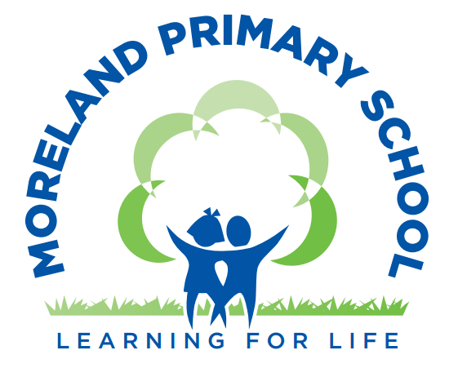

Early Years Education Support Worker

Closing Date: Midnight Monday 9th March 2026



Contents

Letter from the Head Teacher
Advert
Job Description
Person Specification
Guidance for candidates applying for a job with Islington Schools
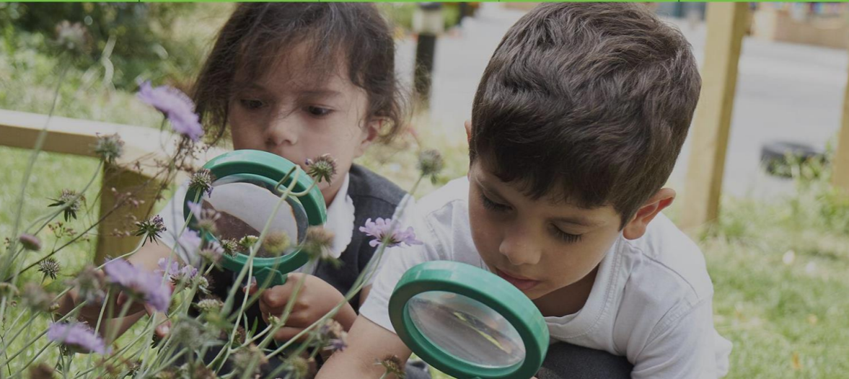
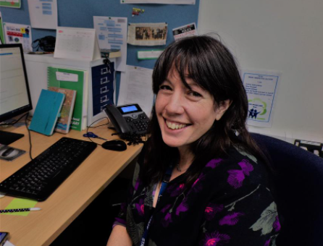

Letter from the Headteacher
Dear Potential Candidate
Thank you very much for your interest in the position of Early Years Education Support Worker at Moreland Primary School and Children’s Centre. Moreland is a unique provision providing excellent care and educational opportunities and outcomes to children from 6 months to eleven years in an amazing new building with spacious, well equipped grounds. The school had a good OFSTED in March 2020 and we are looking for people to join our team on our journey towards outstanding.
Moreland is part of the highly successful St Luke’s and Moreland Federation, a long -standing partnership which has gone from strength to strength. We are also a part of a very forward thinking collaboration of 24 schools called The Future Zone, which provides amazing opportunities for staff and pupils on various levels. We are located in a vibrant community at the heart of London and make the most of all the opportunities and local partnerships this offers us for children. There is exceptional energy and commitment on the part of the staff team and Moreland is an exciting, happy place in which to work and learn. The school’s ‘Learning for Life’ ethos is central to all we do and we are committed to high quality staff training and development.
Our children and families are at the heart of everything we do and we thrive on the diversity and wealth of culture, knowledge and experience that this brings to our school. We are committed to inclusion and all children in Moreland are valued as individuals and have the opportunity to excel. We actively nurture self-belief and Growth Mindset so children feel they can achieve anything with determination, perseverance and hard work. We aim to ensure that all barriers to learning are removed so every pupil reaches their own full potential. The leadership team, staff, children, parents and governors work together in Moreland with collaboration and mutual respect. We are united and learn from each other and succeed together.
'Reaching higher than I dreamed, becoming the person that I want to be, doing the best I can for the world and for me.’- this is our mission.
Please see the school website for information about the school. I would encourage you to come and see our wonderful school for yourself and visits are welcomed.
With best wishes,
Catherine Lawrence (Head teacher)

Why come to Moreland?
Information about the school
Moreland Primary School and Children’s Centre provides a seamless integrated service from pre-birth to the end of year 6. We have the privilege of working in a very rich and diverse community which includes many children and families from a range of backgrounds and cultures and this vibrant blend makes the Moreland community a unique and exciting place to work.
Why come to Moreland?
- The prospect of growing as a professional across a school and Children’s Centre
- Chance to work with other settings through the Federation and within the Future Zone and the opportunities this brings
- Opportunity to work in a setting with an inspiring curriculum
- Enticing Inner London pay rates
- Engaging and highly motivated team
- Highly supportive staff and dedicated governors
- Further Professional Development
- Excellent location at the heart of Islington and near the City of London
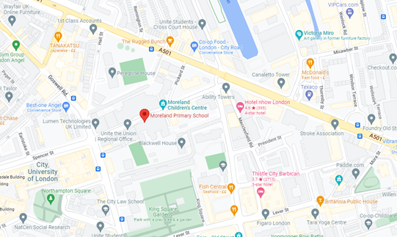
Moreland Primary School and Children’s Centre
Moreland Street
London
EC1V 8BB
Tel: 020 72538144

Ofsted Report
Latest reports on Moreland Primary School and Children’s Centre:
https://files.ofsted.gov.uk/v1/file/50286821
https://files.ofsted.gov.uk/v1/file/50280334

School Website
Moreland Primary School and Children’s Centre website:
https://www.moreland-islington.co.uk/


Moreland Primary School and Children’s Centre
Required for April 2026 (earlier if possible)
Salary range: Scale 3
X 1Early Years Education Support Worker (Term time)
35 hours per week - Actual Salary - £ 24,744 - £ 25,496
Are you considering joining or returning to the Early years workforce? you could be eligible for a £1000 recruitment bonus
Are you a caring, creative and innovative Early Years Educator with a strong commitment to inclusion and the ability to inspire and nurture our youngest children? We are looking to appoint a highly skilled early years support worker, who is committed to high standards of care and education for all children and has a passion for working with under threes. We are looking for someone who: -
- Has experience of working with children under 3
- Is committed to meeting the needs of the whole child and his /her family
- Communicates well with others
- Is reliable and flexible
- Can show initiative and enjoy team work
- Has sound knowledge of the best practice for caring for children under 3
This is an exciting opportunity to join our Early Years Team working in our 0-3’s provision. Moreland is a very happy, thriving school; graded as a ‘good’ school by Ofsted. At Moreland our children and families are at the heart of everything we do and we thrive on the diversity and wealth of culture, knowledge and experience that this brings to our school. We are committed to inclusion and all children in Moreland are valued as individuals and have the opportunity to excel. We have high expectations and aspirations for all.
Staff at Moreland are valued and feel valued and this has a positive effect upon the ethos of our school and on the success and outcomes for children.
You are very welcome to speak to one of the team and to visit Moreland.
Closing date: Midnight Monday 9th March 2026
Shortlisting : Tuesday 10th March 2026
Interview dates: Monday 16th March 2026
www.moreland-islington.co.uk
Islington Schools are committed to safeguarding and promoting the welfare of children and young people, and expects all staff and volunteers to share this commitment. In line with KCSIE 2024 and online search will be conducted for shortlisted candidates in all positions.
Visits
Visits to the school are highly encouraged and can be organised by contacting the school office.
Tel: 020 7253 8144.
Email: admin@Moreland.islington.sch.uk
You can find out more about our school by accessing our website: www.morelandislington.co.uk.

Moreland Primary School and Children’s Centre is committed to safeguarding and promoting the welfare of children and young people, and expect all staff and volunteers to share this commitment.
Job Description
Early Years Education Support Worker
Moreland Primary School and Children’s Centre
Scale 3

PURPOSE OF THE JOB
To work within the 0-3 team to ensure the highest possible standards of education and care for children under 3- socially, emotionally, physically and educationally.
To maintain a safe, secure and nurturing environment for the children.
To follow the Safeguarding policy and all school policies and procedures thereby keeping children safe at all times.

ACCOUNTABLE TO
The post holder is accountable to the Head teacher and Assistant Headteacher EYFS and is line managed by the 0-3 Manager.

POLICY AND LEGAL FRAMEWORK
The post holder will contribute to the smooth running of the school by following all policies and procedures including the staff hand book and Staff Code of Conduct and deliver the most recent national legislation, Education Acts, Keeping Children Safe in Education legislation, Prevent requirements, SEN Code of Practice and EYFS Framework.

TASKS AND DUTIES
1. Planning
To support in planning and preparation of learning activities and sequences of learning appropriate to the needs, interests, experience and existing knowledge of the children in the class.

2. Supporting learning and development
To interact effectively with children to support development in their learning and language development.
To engage in learning activities with groups or individual children having regard for the requirements of the Early Years Foundation Stage curriculum.
To support children to develop the characteristics of effective learning.
To support with the identification of SEND and the learning and development of children with SEND, through inclusive practice - implementing strategies and working towards individual targets as advised by the SENCO or external professionals.

3. Observation, assessment and recording
To observe and assess children’s learning; recording their development and planning activities and next steps in response to this.

4. Key worker responsibilities
Act as a key person for a defined group of individual children providing each child with continuity of care throughout the child’s time at the setting, in partnership with their parent/carers:
- Develop a caring and secure relationship with each key child.
- Help each key child to become familiar with and confident in the setting.
- Look after each key child’s care and welfare needs e.g. dressing, toilet training, and eating, sleeping, being comforted.
- Build trusted relationships with each key child’s parents/carers, ensuring there are regular opportunities to share information on the child’s development at home and in the setting.
- Support each child’s individual learning journey through on-going observation, assessment and planning in partnership with parents/carers and other colleagues
- Complete reviews of the key child, in partnership with multi-agency colleagues and parents/carers, as appropriate (e.g. at aged two, transition records).

5. Relationships and Behaviour Management
To promote and support positive attitudes for learning and a calm, nurturing learning environment through positive behaviour management strategies and trauma informed practice.
To model and promote care and respect for others amongst children in your care supporting children to develop self-regulation and social interaction skills.

6. Communication with parents
To build and maintain co-operative relationships with parents, and to communicate regularly with them regarding pupils’ well being, learning and progress.

7. Learning environment
To work with the 0-3 team to maintain an attractive and stimulating learning environment inside and outside including setting up to a high standard every day and celebrating and documenting children’s work through display, in accordance with the school’s display policy.

8. Policies
To actively follow all policies and take part in whole-school reviews of policies and policies as required.

9. Reflection and Review
To evaluate and reflect on own practice and take on board advice given from observations and monitoring, and act accordingly to address targets given.
To actively participate in supervision and staff performance management procedures.

10. Professional
To keep-up-to-date with current educational thinking and practice, through participation in CPD, training and meetings.
To work collegiately with the 0-3 team and the wider school team maintaining professional and productive working relationships.

11. Equalities
To help ensure the environment, learning activities and resources reflect school policies relating to inclusion, equalities and diversity and that the implications of these policies are reflected in all tasks and duties listed above.

PERSONAL RESPONSIBILITIES
- To use information technology systems as required following the school’s policy for safe use of IT and pupil’s use of IT;
- To carry out the duties of the post in the most efficient and effective manner and to undertake training as appropriate;
- To undertake other duties appropriate to the post that may be reasonably required from time to time;

PERFORMANCE STANDARDS
- To ensure that all services within the areas of responsibility are provided in accordance with Moreland’s commitment to high quality service provision to the children;
- To take on board the school’s ‘Learning for Life’ ethos: which is relevant to children and to the staff team.
- At all times to carry out the responsibilities of the post with due regards to all of Moreland’s key policies including Safeguarding and Child Protection and Health and Safety.
ADDITIONAL
- Be aware of key school plans, policies and procedures, especially the School Priorities, Health and Safety Procedures and Child Protection Procedures.
- Behave professionally and in compliance with the Code of Conduct
- To use and assist others in the use of information technology systems to carry out duties in the most efficient and effective manner.
- To achieve agreed service outcomes and outputs, and personal appraisal targets, as agreed by the line manager.
- To undertake training and constructively take part in meetings, supervision, seminars and other events designed to improve communication and assist with the effective development of the post and post holder.
- The post holder is expected to be committed to the Council’s core values of public service, quality, equality and empowerment and to demonstrate this commitment in the way they carry out their duties.
- Ensure all the services within the area(s) of responsibility are provided in accordance with the Council's commitment to high quality service provision to users.
- Ensure that duties are undertaken with due regard and compliance with the Data Protection Act and other legislation. In particular, respecting the confidentiality of pupil information and respond sensitively to pupils' needs.
- Carry out duties and responsibilities in accordance with the Council’s Health and Safety Policy and relevant Health and Safety legislation.
- At all times carrying out responsibilities/duties within the framework of the Council's Dignity for all Policy. (Equal Opportunities Policy).
Safeguarding Statement
Moreland Primary School and Children’s Centre is committed to safeguarding and promoting the welfare of children and young people, and expect all staff and volunteers to share this commitment.
An ENHANCED DBS check is required for this post.
In line with Keeping Children Safe In Education 2024 an online search will be conducted for shortlisted candidates in all positions.

Person Specification
The person specification is a picture of skills, knowledge and experience required to carry out the job. It has been used to draw up the advert and will also be used in the short-listing and interview process for this post.
You should demonstrate on your application form how you meet each of the following essential criteria. Please ensure that your address each one of the criteria as this will be used to assess your suitability for the post.

Education, Qualifications and Experience
E1 | A relevant level 3 qualification in childcare and/or education and evidence of appropriate subsequent in-service training and professional development.
E2 | Experience of meeting the needs of all children, including those with SEND and social and emotional needs  .
E3 | Recent experience in at least one multi-cultural, inner-city setting in the EYFS and experience of working with children under 3.
Safeguarding
E4 | Display commitment to the protection and safeguarding of children and young people.
E5 | Up-to-date knowledge and understanding of relevant legislation and guidance in relation to working with, and the protection of, children and young people.
E6 | Will co-operate and work with relevant agencies to protect children.
Knowledge, Skills and Ability
E7 | Knowledge and experience of how children learn through play and of delivering play based activities and learning environments, inside and outside, that support the development of the characteristics of effective learning.
E8 | Knowledge of the EYFS curriculum and an understanding of how children 0-3 learn including the importance of the Prime Areas of learning.
E9 | Understanding of assessment of children in the EYFS and how to move learning on through identifying and planning children’s next steps.
E10 | Ability to effectively manage children’s behaviour in a positive way supporting the development of self- regulation and with a commitment to trauma informed practice.
E11 | Demonstrate a commitment to inclusion and equal opportunities in particular experience of working with EAL and SEND learners and knowledge of how to support these children’s learning and development.
E12 | A willingness to work closely with colleagues including the SENCO to ensure the inclusion of all children in the setting.
E13 | The ability to build strong, caring professional relationships with young children based on an understanding of attachment theory and to work closely with parents to support transition into the setting and when moving classes.
E14 | Work collaboratively, creating and maintaining effective partnerships with other staff, professionals and families.
Personal Qualities
E15 | A sense of integrity and commitment to the school ethos and vision including meeting the needs of all children and having high aspirations for children.
E16 | To contribute to the supportive ethos of the school as an effective, efficient team player demonstrating good interpersonal skills and a willingness to work collaboratively as part of a large EYFS team.
E17 | Relate well to children, staff and parents /carers and care about their individual needs, respecting diversity, equality and inclusivity and the ability to deal appropriately and professionally with sensitive issues.
E18 | To have a positive outlook, enthusiasm, and a good sense of humour.
E19 | Ability to adapt to changing circumstances and new ideas in a positive and creative manner showing a growth mindset.
Other Professional Skills
E20 | The ability to communicate clearly both orally and in writing and demonstrate good levels of literacy and numeracy.
E21 | IT skills commensurate with the requirements of the role.
Commitment to Equal Opportunities
E20 | Demonstrate a commitment to equality and the ability to adhere to the Council’s Dignity for All policy.

