Job description
Coach Builder / Panel Beater / Vehicle Sprayer
- Grade: PO1
- Reports to: Principle Workshop Manager
- Direct reports: None
- Your team: Fleet & Workshops
- Service area: Environment & Commercial Operations
- Directorate: Environment & Climate Change

Special requirements of the post
Workstyle: Frontline (Full presence, working in the borough full time)
- Colleagues whose role is delivering frontline services to residents, visitors, businesses and/or other colleagues while present in the borough and activities cannot be done remotely.
This is a safety critical post and will be subject to the council’s drug and alcohol policy

Our mission
Islington is a place rich with diversity and culture. As a council our sense of purpose couldn’t be clearer: we serve. It’s in the logo. We are committed to challenging inequality in the borough and as one of the largest employers we know that to look after the place and the planet, we have to look after our people. Together we can change the future.
To do this, everyone who works at Islington Council lives by a set of values which guide us in everything that we do: collaborative, ambitious, resourceful, and empowering. They spell out ‘CARE’, which is what we think public service is all about.

Overview of the role
The Coach Builder is responsible for building, refurbishing, repairing and refinishing a wide range of fleet vehicles, including buses, coaches vans, HGVs, cars and cargo bicycles- to a high standard of safety, structural integrity and cosmetic finish. The role covers structural repairs, panel fabrication, panel beating, interior fit-out, glazing, door systems, trims, painting and finishing.

Key responsibilities
Please list each key responsibility of the role (Maximum of 10-12 bullet points):
- Inspect and diagnose body damage, corrosion, and structural issues on fleet vehicles.
- Fabricate, repair and align body panels (aluminium, steel, GRP, plastics), floors, subframes and brackets.
- Conduct structural sectioning, bonding/riveting, and approved MIG/TIG welding processes.
- Carry out accidental-damage repairs including pulling, jig alignment, reshaping and panel replacement.
- Remove/reinstall interiors, seats, handrails, floors, ramps, doors, glazing and trim.
- Prepare surfaces for painting and apply compliant primers, basecoats, topcoats and lacquer.
- Complete documentation including job cards, parts requests, and quality control checklists.
- Maintain high workshop housekeeping standards (5S), tool control and safety compliance.
- To work safely at all times in accordance with all relevant Health and Safety legislation, Council policy and specific safety instructions.
- To complete all tasks making efficient use of resources, minimising wastage and complying with all Environmental legislation and good practice.
- To provide flexibility to cover alternate working hours to cover absence of other staff etc as instructed by the Workshop Managers.
- Completion of training and satisfactory assessment of knowledge as required by Corporate Fleet and Transport Manager. This may include manufacturer product courses, legislation relating to work areas and health & safety related training.
- Provide input into vehicle specification and fault resolution. To undertake other duties commensurate to the grade of the post.
- Adhere to key performance indicators related to the delivery of the role including:
  - First-time quality and low rework
  - Meeting planned turnaround times
  - Compliance with repair standards and safety processes
  - Strong housekeeping and tool control

ADDITIONAL:
- To use and assist others in the use of information technology systems to carry out duties in the most efficient and effective manner.
- To achieve agreed service outcomes and outputs, and personal appraisal targets, as agreed by the line manager.
- To undertake training and constructively take part in meetings, supervision, seminars and other events designed to improve communication and assist with the effective development of the post and post holder.
- To carry out duties and responsibilities in accordance with the council’s commitment to customer service excellence and ensure compliance with the customer care standards.
- To be committed to the Council’s core values of public service, quality, equality and empowerment and to demonstrate this commitment in the way duties are carried out.
- To ensure that duties are undertaken with due regard and compliance with the Data Protection Act and other legislation.
- To carry out duties and responsibilities in accordance with the Council’s Health and Safety Policy and relevant Health and Safety legislation.
- At all times to carry out responsibilities/duties within the framework of the Council's Dignity for all Policy. (Equal Opportunities Policy).
- Ensure adherence to legal, regulatory, and policy requirements under GDPR, Health and Safety, Employee Code of Conduct and in your area of expertise by identifying opportunities and risks, and escalating issues as necessary.

Person specification
Your application form needs to demonstrate how you fulfil the role's requirements. It is essential to address the criteria, as this will be used to evaluate your suitability for the position.

Essential and desirable criteria
Essential: the basic requirements that must be met for someone to be considered for a particular job. These criteria are mandatory and cannot be negotiated. Essential criteria directly impact the core qualifications or skills necessary to perform the job effectively.
Desirable: the additional qualities, skills, or qualifications that would be advantageous for a candidate to possess but are not mandatory. Not meeting them does not automatically disqualify someone from consideration for the job. This also allows candidates who do not possess certain desirable criteria the opportunity to explain how their other knowledge, experience and skills relate to these and what they may be in the process of doing or willing to do to achieve these.

Knowledge, experience, and skills
Point | Criteria description | Essential/desirable
1 | Formal Qualification(s) in Vehicle body repair or Coachbuilding such as City & Guilds parts 1,2+3 / BTec National Certificate or NVQ Level 3 | Essential
2 | BS10125 familiarity; ATA accreditation | Desirable
3 | Welding certifications | Essential
4 | Category B driving licence minimum (Vocational license desirable) | Essential
5 | HV/EV safety awareness | Essential
6 | Proven coachbuilding, body repair, panel beating experience | Essential
7 | Skilled in dent repair, heat shrinking, pulling systems and jog alignment | Essential
8 | Competent in MIG and plastic welding (TIG desirable) | Essential
9 | Strong fabrication and measuring skills | Essential
10 | Able to read technical drawings and work with precision | Essential
11 | The post requires a clean drivers license | Essential
12 | Fluency in English to speak with confidence, accuracy, and with appropriate vocabulary, sufficient to perform the role effectively. | Essential
13 | This post is subject to the council’s policy on pecuniary and personal interest
14 | This post is designated as politically restricted

Our accreditations
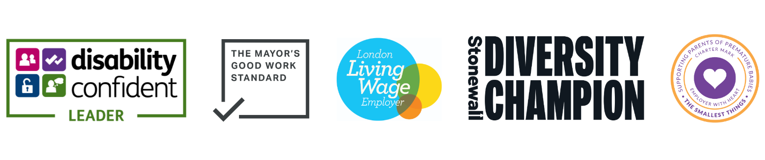 Our accreditations include Disability Confident Leader, The Mayor’s Good Work Standard, London Living Wage Employer, Stonewall Diversity Champion, and Employer with Heart.

